Information for Proper Posting & Laser Area Sign Templates

All signs must be conspicuously displayed at locations where best serve to inform all.

Signal Words Posting

- Class 3R Laser Area: An area that contains a Class 3R laser or laser system should be posted with the appropriate sign described below.
- Class 3B or Class 4 Laser Area: An area that contains a Class 3B or Class 4 laser or laser system shall be posted as described below with the appropriate sign described in this document.
- Temporary Laser Controlled Area (Class 3B and Class 4): The exterior boundary of a temporary laser controlled area shall be posted with a Notice sign as described below.

Signal Word Purpose (Class 3B or Class 4)

The purpose of a laser area warning sign is to convey a rapid visual hazard-alerting message that:
- Warns of the presence of a laser hazard in the area
- Indicates specific policy in effect relative to laser controls
- Indicates the severity of the hazard (e.g., class of laser, NHZ extent)
- Instructs appropriate action(s) to take to avoid the hazard (e.g., eyewear requirements)
The signal words have the following meanings:
- "DANGER" indicates an imminently hazardous situation that, if not avoided, will result in death or serious injury. This signal word is to be limited to the most extreme conditions. The signal word "Danger" indicates that death or serious injury will occur if necessary control measures are not implemented to mitigate the hazards within the laser controlled area. This signal word is designated to Class 4 lasers with high (e.g., multi-kilowatt) output power or pulse energies with exposed beams.

- "WARNING" indicates an imminently hazardous situation that, if not avoided, could result in death or serious injury. The signal word "Warning" shall be used on laser area warning signs associated with lasers and laser systems whose output exceeds the applicable MPE for irradiance, including all Class 3B and most Class 4 lasers and laser systems.

- "CAUTION" indicates a hazardous situation that, if not avoided, could result in minor or moderate injury. It may also be used without the safety alert symbol as an alternative to "NOTICE." The signal word "Caution" shall be used with all signs and labels associated with Class 2 and Class 2M lasers and laser systems that do not exceed the applicable MPE for irradiance.

- "NOTICE" is the preferred signal word to address practices not related to personal injury.
Message Panel Information
Adequate space is available within each templates message panel to allow for the inclusion of pertinent information. Add the addition information to the applicable template below:
- The hazard class of the laser controlled area.
- Special precautionary instructions or protective action that may be applicable. For example:
  - Laser Eye Protection Required
  - Invisible Laser Radiation
  - Do Not Enter When Light is Illuminated
  - Restricted Area, Authorized Personnel Only

- The highest hazard class of the laser or lasers within the laser controlled area.
- Additional information such as follows:
  - The optical density for eye wear to be worn within the area – include the most common for a tunable laser/laser system
  - Type of Laser(s)
  - Wavelength(s) – List most common for a tunable laser/laser system
  - Max Power/Energy of Laser – List most common for a tunable laser/laser system

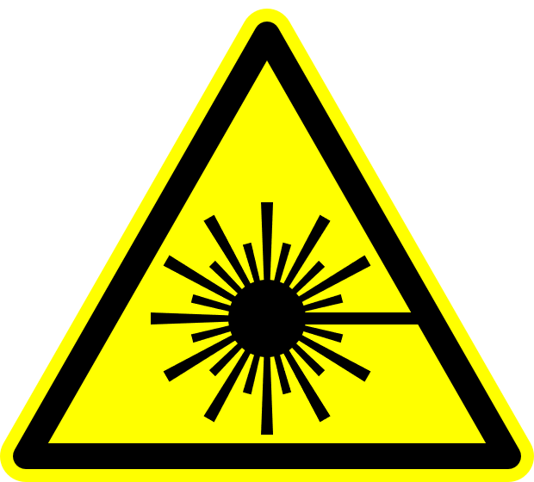
Class 3R Laser In Use

Do not stare into beam or view directly with optical instruments.

Laser Type:
Wavelength: nm
Power/Energy:

Emergency Contact:

CAUTION

!
Radiation and Laser Safety Emergency Contact: (614) 561-7969
Class 3B Laser Controlled Area

Avoid eye or skin exposure to direct or scattered radiation.

Do Not Enter When Light is Illuminated

Laser Eye Protection: OD ≥
Laser Type:
Wavelength: nm
Power/Energy:

Emergency Contact:

WARNING

!
Radiation and Laser Safety Emergency Contact: (614) 561-7969
Class 4 Laser Controlled Area

Avoid eye or skin exposure to direct or scattered radiation.

Do Not Enter When Light is Illuminated

Laser Eye Protection: OD ≥
Laser Type:
Wavelength: nm
Power/Energy:

Emergency Contact:

WARNING

!
Radiation and Laser Safety Emergency Contact: (614) 561-7969
Class 4 Laser Controlled Area

Avoid eye or skin exposure to direct or scattered radiation.

Do Not Enter When Light is Illuminated

Laser Eye Protection: OD ≥
Laser Type:
Wavelength: nm
Power/Energy:

Emergency Contact:

DANGER

!
Radiation and Laser Safety Emergency Contact: (614) 561-7969



Emergency Contact:

NOTICE

Radiation and Laser Safety Emergency Contact: (614) 561-7969

