Biosafety Cabinets (BSC) Guidance
A biosafety cabinet (BSC) is a primary containment device used with biological material. The most common cabinet is the Class II Type A2 biosafety cabinet. While handling biological agents, it is the biological equivalent of using hazardous chemicals inside a chemical fume hood. Like a chemical fume hood, a biosafety cabinet protects the user from hazardous material using directional air flow.
A key distinction is that biosafety cabinets have an internal blower motor which recirculates potentially contaminated air through HEPA filters. HEPA filters are designed to remove any biological agent from the air passing across the filter. Air leaving the chamber passes through the exhaust HEPA filter which prevents contamination of the lab or environment. Air recirculating through the chamber passes through the supply HEPA filter. This creates a sterile environment inside the chamber which is ideal for doing tissue culture work or sterile microbiology. Thus, biosafety cabinets are sometimes referred to as Tissue Culture hoods (though biosafety cabinet is the proper term).
Depending on if and how the cabinet is connected to the building exhaust, small amounts of volatile or toxic chemicals can be handled inside a biosafety cabinet while doing sterile biological research.
Contents
How does a Biosafety Cabinet work? 2
What is a HEPA filter and how does it work? 3
Connection type 5
Non-ducted: 5
Canopy connection: 6
Airflow Alarms 7
What are some Best Practices I should be aware of? 8
Before Starting Use 8
During use 8
After use 10
Certification 11
Maintenance 11
Routine Cleaning 11
Annual/Semi-annual cleaning 12
Repair 14
Training 15
Emergency response 15
Spills clean up 15
UV Lights 16
Limitations 16
Guidance 17
References 17
When should I contact Biosafety? 17
Guidance 18
Other ventilation equipment 18
Chemical Fume Hood 19
Clean bench/laminar flow hood 20
Animal transfer station 20
Class I BSC 20
Class II Type A1 BSC 20
Class II Type B1 BSC 21
Class II Type B2 BSC 21
Class II Type C1 BSC 21
Class III BSC (“glove box”) 21
References 22
Appendix A 23

How does a Biosafety Cabinet work?
The Class II Type A2 biosafety cabinet is the most common cabinet on campus. It uses a curtain of air and HEPA filters to provide both containment and a sterile environment. Below is a schematic explaining how the cabinet functions:
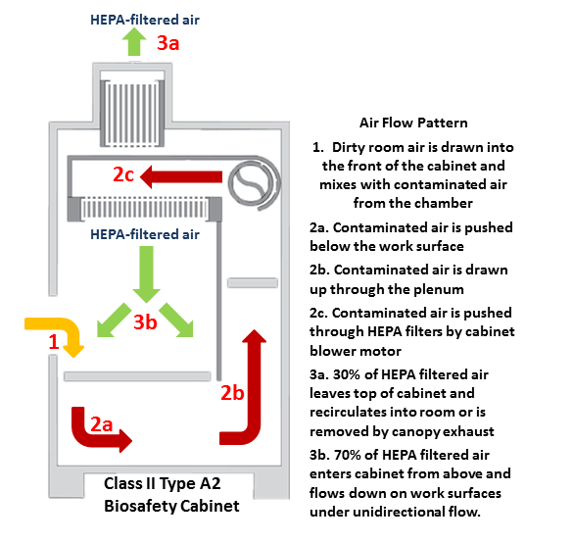
- Provides 3 levels of protection
  - Personnel - Air curtain and HEPA filters protect users from biohazardous aerosols generated inside the chamber
  - Sample Protection – Recirculating and unidirectional HEPA filtered air protect samples from contamination from unsterile lab air
  - Lab/Environmental protection – HEPA filtered exhaust from top of cabinet protects lab environment from contamination by biohazardous aerosols generated inside the chamber
- Suitable for use with any biological agent
  - Bacteria, viruses, viral vectors, fungi, parasites, human/animal tissue and cell lines, prions, etc.
- Must not be used with
  - Large amounts of volatile or toxic chemicals
  - Concentrated flammable chemicals
  - Volatile radionuclides
  - Open flames

What is a HEPA filter and how does it work?
HEPA filter (High Efficiency Particulate Air or High Efficiency Particulate Arresting filters) are fibrous filters that remove particles from air passing through them. HEPA filters consist of a metal or wood frame holding a long, folded strip of cellulose or borosilicate fiber. The edges are sealed with Epoxy or polyurethane. The images and diagrams below explain how the filters work:
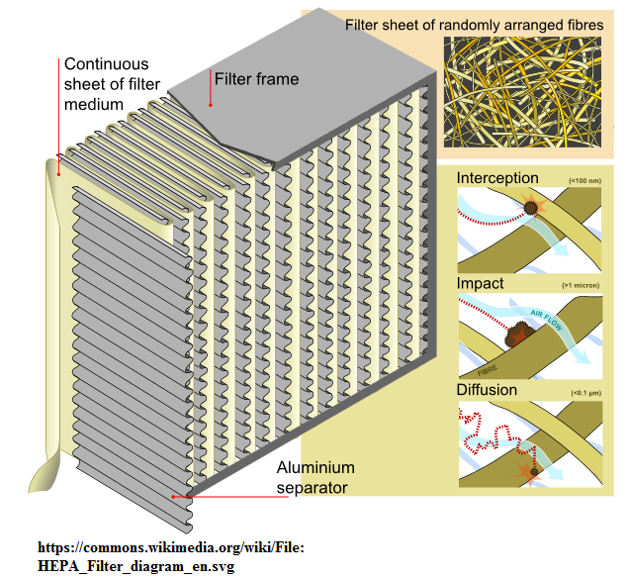
- Fibrous material is used to separate biological material from air passing through the filter
- Particles are “trapped” by the fibers and removed from the air as it flows through the filter
- Multiple, folded sheets of fibrous material drastically increase surface area of filter
- Increased surface area drastically increases the efficiency of filtration
To be designated as HEPA, the filter must remove 99.97% of all particles at a 0.3 um size. This particle size is the Most Penetrating Particle (MPP) size. Particles above and below this size are removed with greater efficiency by different mechanisms as explained below:
- Filters biological aerosols through several mechanisms
  - Fast moving particles filtered through direct impaction with fibers
  - Large particles removed by straining effect when particle trapped between two fibers
  - Smaller Particles removed by interception
  - Very small particles move by Brownian motion and are removed by diffusion when they come in contact with fibers
  - Negatively charged particles (such as some viral particles) removed by electrostatic attraction to slightly positive charged of the fibers
- HEPA filter are 99.97% efficient at removing particles of 0.3 microns which is the size of particle that has the highest penetration
- Particles larger and smaller than 0.3 microns are removed with higher overall efficiency due to the methods discussed above

Connection type
- Nonducted recirculating biosafety cabinet (also called unducted or free standing)
- Canopy/thimble connected biosafety cabinet (none on UNT campus)

Non-ducted:
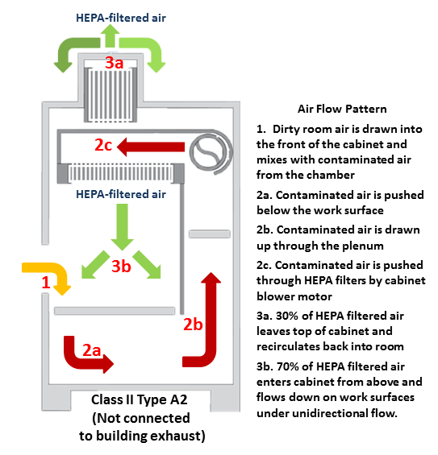
- Class II type A2 cabinets are designed to function independently from the building or room exhaust (non-ducted BSC)
- Biological material passes through the exhaust HEPA filter of the cabinet and is removed
- Exhaust air can safely recirculate back into lab if only handling biological material at BL1 or BL2 containment
- Volatile or toxic chemicals and volatile radionucleotides require a canopy connected cabinet (see examples below)
- Work at BL2+ containment requires a canopy connected cabinet as an extra precaution
- The diagram above shows the proper airflow for a non-ducted Class II Type A2 BSC

Canopy connection:
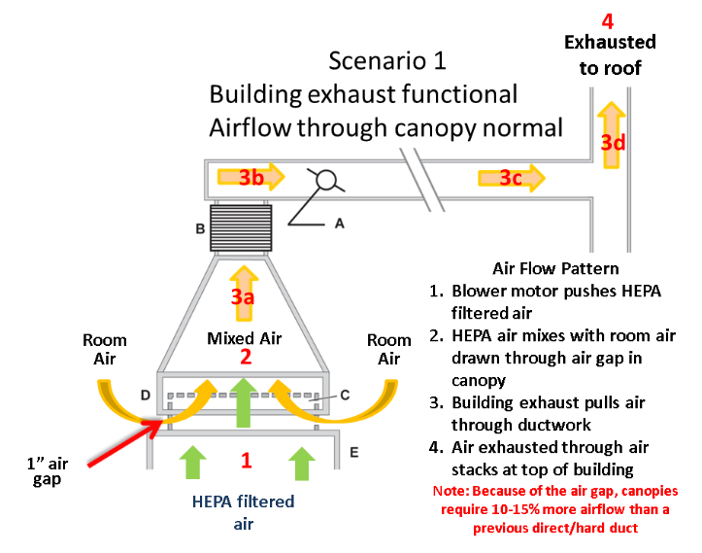
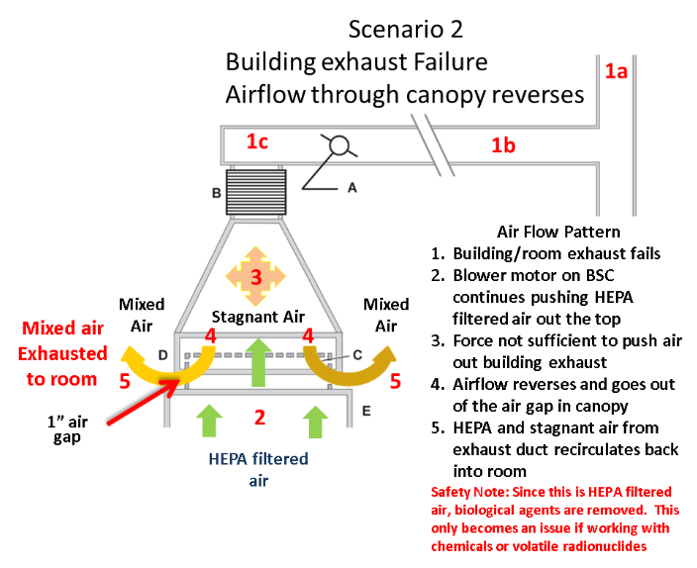
- Class II Type A2 cabinets can be connected to the building exhaust through the addition of a canopy or thimble connection
- This leaves a small air gap between the exhaust of the cabinet and the connection to the building exhaust which avoids the airflow reversal problems of hard ducted cabinets describe above
- Can be used with minute amounts of volatile or toxic chemicals or volatile radionuclides
- The HEPA filters will not remove chemicals but these particles will be exhausted through the building exhaust
- If building exhaust fails, the canopy will allow the exhaust to flow back into the room rather than pressurizing and blowing non-HEPA filtered air back into the operators' face
- NSF standard 49 also calls for the addition of a canopy airflow alarm which warns operators that building exhaust is no longer sufficient to remove the exhaust air from the canopy

Airflow Alarms
- NSF standard 49 requires that canopy connected Class II Type A2 biosafety cabinets have an airflow alarm
- Airflow alarms monitor the airflow passing through the canopy and measures whether it is sufficient to capture the exhaust air exiting the biosafety cabinet
  - When airflow is disrupted (typically because an exhaust fan has failed or lost capacity), the alarm will alert the operator they have lost containment of exhaust and the cabinet is now recirculating into back into the lab
  - This does not pose a safety risk for experiments only handling biological agents at BL1 and BL2 containment since the exhaust air has already passed through the HEPA filters
  - For experiments using minute amounts of volatile toxic chemicals or volatile radionuclides this could cause an exposure risk depending on the nature of and concentration of the material
- Alarms can be integrated into the cabinet or installed as a separate piece of hardware
Ready/Normal state
- Alarm functioning properly
- Building exhaust appropriate to capture canopy exhaust
- Generally indicated by a GREEN indicator light; t\for the Rooster, the Green LED flashes every 2 seconds
- If airflow drops below threshold for more than 5 seconds, alarm will go into alarm state
Alarm State
- Indicates low building exhaust airflow
- Red light flashes quick and audio alarm sounds.
- Audio alarm can be silenced by pressing the “Reset” or “Mute” button; the red light will continue to flash
- Alarm will automatically return to normal operation state when proper airflow is re-established (this is a default setting for the Rooster alarms but may vary depending on alarm style and settings)
Operator response
- Response action will vary depending on the type of material being used:
  - Biological material only (no toxic chemical or volatile radionuclide material)
    - Silence audible alarm by pressing “Reset” or “Mute” button
    - Finish experiment
  - Minute volatile chemical or radionuclide material, or BL2+ containment work
    - Stop experiment and close sash
    - Silence audible alarm by pressing “Reset” or “Mute” button
- Alert BSO and place warning sign on cabinet
Error State
- Some alarms such as the Rooster alarm have an error state represented by a yellow caution light
- This state indicates the alarm has received a fault (sometimes caused by a power failure)
  - Reset button will light up yellow and an audible alarm will sound
  - Unplug alarm power, wait 10 seconds, restore power plug
- Alarm will restart and automatically return to normal state

What are some Best Practices I should be aware of?
Some basic good work practices will protect you and maintain the sterility of your samples while using a biosafety cabinet. These are basic guidelines and reminder.

Before Starting Use
- Turn on blower and light and allow cabinet to run for 2-3 minutes prior to use to purge stagnant air inside BSC
- Ensure window sash is at proper operating height (typically 8 or 10 inches according to manufacturer instructions)
- Monitor alarms, pressure gauge or flow indicators for any major fluctuations; a piece of tissue or Kimwipe held at the sash opening is a quick test to ensure the cabinet has proper airflow (tissue should be pulled inward)
- Avoid bringing exposed skin into the chamber - gloves should be tucked underneath the cuff of your lab coat or your lab coat should be tucked beneath the cuff of your glove (depending on your preference)
- Spray appropriate disinfectant on paper towel and wipe cabinet surfaces from back to front (clean to dirty); a tool such as a swifter handle can be used for hard to reach spaces - Do NOT place your head inside the cabinet.
- Wipe all materials with appropriate disinfectant before placing inside the chamber to ensure a sterile environment is maintained
- Ensure the back and front grates are clear:
  - Equipment near back grates should be at least 1 inch away from the grates
  - Do not place anything on the front grates (such as lab notebooks or protocols)
- Before use, check the certification sticker to ensure the cabinet has been certified within the past year; if certification has expired, do not use the cabinet and alert your PI

During use
- Bring material all material into the chamber prior to beginning experiments
- Perform experiments at least 4-6 inches before the front grill to ensure best unidirectional airflow and containment
- Avoid disrupting the air curtain:
  - Use slow, controlled movements
  - If you must bring things into and out of the chamber, moving using an inward and outward motion
  - Avoid moving your hands side to side
  - Avoid traffic while working in the cabinet - anyone walking by will disrupt the air curtain
- Waste should be kept inside the cabinet and only removed at the end of the experiment - this avoids frequent disruption of the air curtain
- Work “clean” to “dirty”:
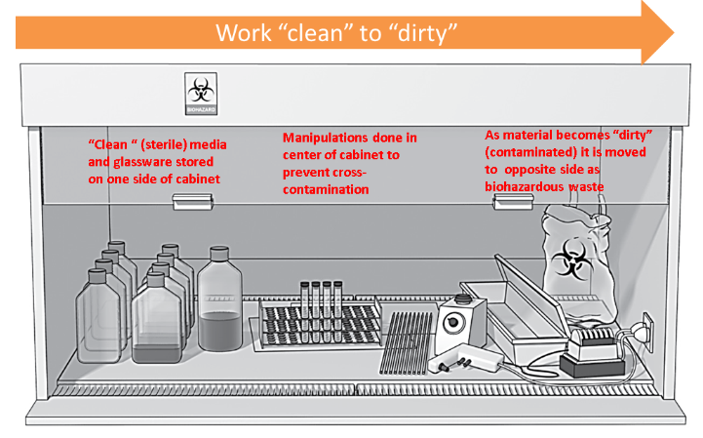
Use an appropriately set up vacuum line if necessary:
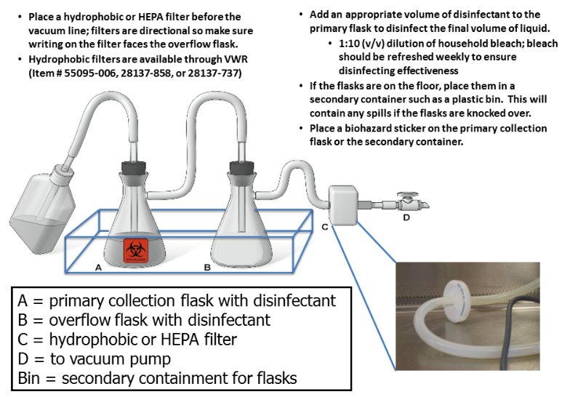
Do not use an open flame in a biosafety cabinet
  - Chamber is a sterile environment and does not require heat source for sterility
  - Disposable or autoclavable loops/spreaders are available to replace flame sterilization of metal loops or metal/glass plate spreaders
  - Heat from an open flame can disrupt air currents in the chamber
  - Heat can damage supply HEPA filters
  - UNT prohibits use of open flames outside of special circumstances
  - Other heat sources in a BSC (such as ceramic incinerators) require prior UNT IBC review and approval

After use
- Leave BSC blower running for 2-3 minutes to purge all the chamber air
- Wipe down materials with appropriate chemical disinfectant and remove everything from cabinet
- Wipe down cabinet surfaces with appropriate chemical disinfectant working clean to dirty areas
- UV lights:
  - Are not a dependable disinfection method – chemical disinfection and proper use of the cabinets are sufficient to maintain sterility
  - Are no longer recommended by American Biological Safety Association (ABSA International, 2000), NSF (2004), Centers for Disease Control (CDC, 2009)
  - Have no performance verification standards for testing effectiveness of disinfection
  - Bulbs have a limited shelf life
  - Research found labs were not maintaining bulbs (replace every 6 months and wipe weekly)
  - Newer cabinets are no longer constructed with UV lights as a default option
  - Please see UV light section for additional information for labs who choose to use UV lights
- Turn off cabinet, close sash, remove personal protective equipment, and wash hands

Certification
The National Institutes of Health (NIH) requires biosafety cabinets to be certified on an annual basis. Labs which conduct research in a BSC which has not be properly certified are in violation of UNT policy and of the NIH guidelines and could have their grant funding impacted. NSF/ANSI standard 49 state the certification standards required for proper certification of biosafety cabinets:
- RMS schedules and funds annual certification of BSCs in the late summer/fall.
- Labs/PIs that choose not be certified on this schedule are responsible for ensuring their cabinets are properly certified
- Annual certification outside of this schedule generally costs around $130
- Certification tests to ensure the cabinet will contain biological material:
  - The HEPA filters are challenged with a particle and the penetration levels are measured to ensure filter integrity
  - All the airflow patterns and flow rates are checked and adjusted to make sure they meet manufacturer parameters
  - Airflow alarms on canopy connected cabinets are tested and calibrated
- BSCs that are not currently certified for use must have signage posted (appendix A) that they are not to be used until certified
The following vendor has been approved by RMS/ Biosafety. If there is another vendor you are considering, please contact your biosafety officer for guidance. The contact information for the vendor for the UNT campus is:
- Titan Tech, Inc:
  - Contact: Brady Eden
  - Phone: 817.723.8537
  - Email: brady@titantechinc.org

Maintenance
Biosafety cabinets should be disinfected and cleaned before and after each use. On an annual or semi-annual basis, the catch basin below the work surface should be cleaned to prevent contamination:

Routine Cleaning
- Surface decontamination prior to using and after each experiment
  - EPA registered product such as quatricide, PREempt, Lysol professional spray, etc.
  - 10% household bleach (>0.5% NaOCl final concentration) can be used on a biosafety cabinet but you must always follow with a sterile water or 70% ethanol rinse step to prevent corrosion of the stainless steel work surfaces
- Items kept in BSC can be source of contamination & should be surface decontaminated between experiments

Annual/Semi-annual cleaning
- Every 6-12 months clean the catch basin beneath the work surface
- Keep BSC running and sash at working level (8-10 inches) to maintain containment
- Do not put your head inside the chamber
- This is generally a two person job
- Surface decontaminate work surface and sides prior to lifting
- Newer cabinets may have tabs to hold work surface elevated during cleaning
- Older cabinets may have obstructions you will need to maneuver around and work station may need to be removed from cabinet during cleaning
- Always surface decontaminate the bottom of work surface before removing from cabinet
- Images below show how to lift work surface to access catch basin
  - Note: This may vary depending on depending on your style and model of cabinet
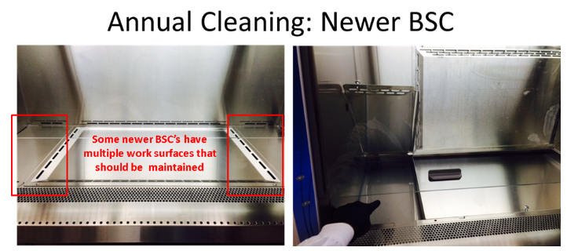
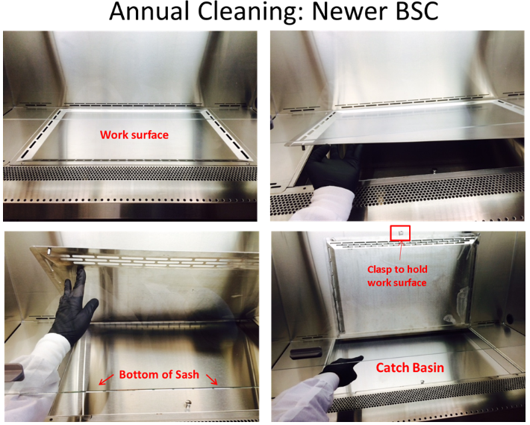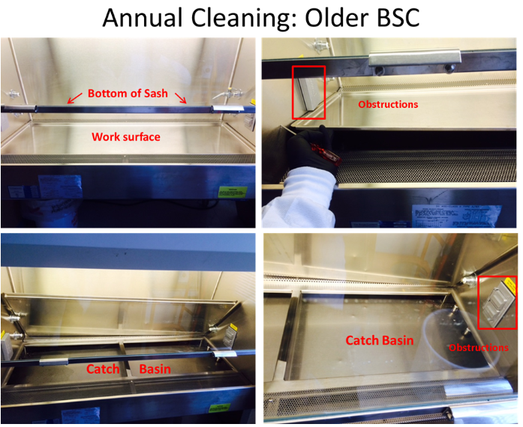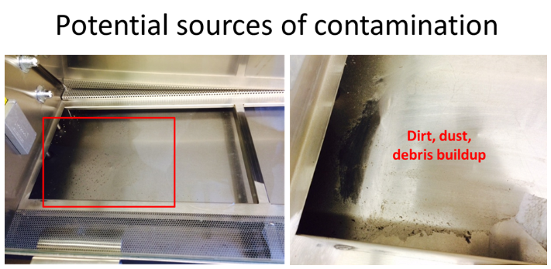

Repair
- PIs/Laboratories are responsible for repairs of BSCs
- Certification companies can also often perform repairs on biosafety cabinets
- Recertification is required after any repairs
- HEPA filters repair
  - Can last for 5-10 years or longer depending on usage and lab conditions (i.e. humidity and cleanliness of the lab air)
  - Replacement filters require a full gaseous decontamination of the biosafety cabinet before filters can be replaced and the old filters removed
  - Most cabinets have 2 filters - a supply & an exhaust (Some cabinet models may have a third filter)
  - This is generally a 2 day process
- Blower motor
  - Blower motors can last for a decade or more
  - As they age, they lose capacity and must be replaced
  - The cabinet must be gaseous decontaminated before the motor can be replaced
  - This is generally a 2 day process
- Sensors, sash, & controls
  - These parts can wear out over time
  - May require gaseous decontamination depending on where the part is located and whether it could have come in contact with contaminated air
- Gaseous decontamination
  - Required for replacement of HEPA filters, repair of blower motors, or disposal of biosafety cabinet
  - Multiple methods
    - Vaporous hydrogen peroxide (VHP) is the recommended method
      - Shorter decontamination time
      - Generally an overnight process
      - Lower chemical safety risk than formaldehyde gas
      - Cabinet is sealed during decontamination, but lab is generally inaccessible for 8 hours
      - Generally costs around $500
    - Formaldehyde gas
      - Longer decontamination time (generally 24 hours)
      - Higher chemical safety risk due
      - Gas must be scrubbed after decontamination
      - Cabinet sealed but lab is inaccessible during decontamination
      - Generally costs around $500

Training
Researchers should receive training prior to working in a biosafety cabinet. Often, labs will have a more experienced researcher provide training to a new lab member.

Emergency response

Spills clean up
If a spill occurs in the cabinet on the work surface:
- Keep cabinet running to contain aerosols
- Follow the normal biological spill cleanup protocol:
  - Gather your biological spill kit
  - Remove broken glass using mechanical means (tongs or dust pan + broom) and place in biosharps container
  - Disinfect tools
  - Cover spill with paper towels
  - Apply disinfectant (typically 10% final concentration of household bleach, at least 0.5% sodium hypochlorite NaOCl) to paper towels starting at the outer edges and working inward using a circular manner to pushed spilled material to center
  - Allow 20 minute contact time
  - Dispose of material as biohazardous waste
  - Perform another surface decontamination
  - Follow with sterile water or 70% ethanol rinse step to remove residual bleach and protect stainless steel finish
If a larger spill overflows into catch basin under the cabinet work surface:
- Keep cabinet running
- Ensure drain valve is closed
- Pour disinfectant onto surface and through grills
- Allow at least 20 minute contact time
- Use mechanical means to pick up broken glass and dispose of in biosharps container
- Soak up liquid with paper towels
- Connect flexible tubing to drain valve
- Drain basin into disinfectant filled container
- Dispose of exposed materials in biohazardous waste
- Lift work surface and decontaminate catch basin (see maintenance section above for details)
- Follow with sterile water or 70% ethanol rinse step to remove residual bleach and protect stainless steel finish

UV Lights
The use of UV light sterilization has been a traditional staple of sterile tissue culture work in biosafety cabinets. However, current guidance does not recommend relying on UV sterilization to ensure disinfection. Multiple studies found that labs were not properly maintaining their UV lights and there are no established standards for testing UV lights. Below is a discussion of the limitations of UV lights, followed by some guidance for labs which still chose to continue use of UV lights.

Limitations
- Only effective for surface decontamination of areas exposed to the UV light; areas in the shadows of equipment or beneath paper/plastic will not be decontaminated
- UV bulbs have a limited shelf life before they lose effectiveness
  - Average 6-8 month shelf life
  - Light will shine blue even after expired
  - Only 85% efficiency after 6000 hours of use
- Particles can build up on the surface of the bulb
  - Reduces efficiency
  - Requires weekly surface decontamination
- No NSF/ANSI standards for testing
- No longer recommended
  - American Biological Safety Association (ABSA International, 2000)
  - National Sanitation Foundation (NSF International 2004)
  - Centers for Disease Control and Prevention (CDC , 2009)
- Research showed labs were not replacing and maintaining regularly which generated a false sense of security regarding sterility
- Newer cabinets are not constructed with UV lights and UV lights must be added as a custom feature (required additional cost)
- UV light use can lead to exposure and harm upon skin or eye contact
- UNT Biosafety does not recommend the use of UV lights

Guidance
- Do not use UV lights while research is being performed in the cabinet; newer cabinets have interlocks that prevent the UV light from activating when the sash is open, but older cabinets may not have this safety feature
- Minimize equipment stored in the BSC to prevent unnecessary exposure; UV light will degrade plastic over time (such as pipettes, waste containers, and vacuum line tubing)
- Use appropriate exposure time
  - Most agents are inactivated after 10-15 minutes
  - Maximum sterilization time should be limited to 30 minutes - after 30 minutes there is no additional benefit.
  - Turn UV light off after sterilization time to conserve bulb life and energy (sustainability)

References
For additional information, please refer to the following articles:
- American Biological Safety Association (2000). Position Paper on the Use of Ultraviolet Lights in Biological Safety Cabinets
- Burgerner, J. (2006). Position Paper on the Use of Ultraviolet Lights in Biosafety Cabinets. Applied Biosafety 11 (4): 228–230
- Meechan P, Wilson C (2006). Use of Ultraviolet Lights in Biological Safety Cabinets: A Contrarian View. Applied Biosafety 11 (4): 222–227
- Centers for Disease Control and Prevention; The National Institutes of Health. Biosafety in microbiological and biomedical laboratories. 5th ed. Washington, DC. 2009
- NSF International (NSF); American National Standards Institute (ANSI). NSF/ANSI Standard 49-2007. Class II (laminar flow) biosafety cabinetry. Ann Arbor (MI); 2004

When should I contact Biosafety?
- Anytime you need guidance and cannot find the answer by consulting our guidance materials (including this webpage)
- When you plan to purchase a new biosafety cabinet - Biosafety can
  - Help with the risk assessment to determine the proper class/type of cabinet to meet your needs
  - Give guidance on whether you need a canopy connection or if your cabinet can safety recirculate back into the room (remain non-ducted)
  - Give guidance on proper placement of your new cabinets:
    - In general, cabinets should be located near the rear of labs outside of well-travelled areas - foot traffic can interfere with the containment
    - Cabinets must not be located near doorways and entrances; opening and closing of nearby doors will interfere with the airflow & break containment
- When you need to relocate a biosafety cabinet

Guidance
- No open flames are allowed in biosafety cabinets per UNT Guidance
- Guidance enacted following incidents at other universities involving fires inside biosafety cabinets (post incident images from MIT shown below)
  - Researcher was using a "touch-o-matic" style bunsen burner to flame sterilize reusable equipment
  - Ethanol container caught fire and exploded shattering sash & sending flaming material out front of cabinet
  - Flaming material burned 17 gallon sharps container to the ground
  - Cabinet was destroyed & had to be replaced
  - Fortunately, researcher had stepped away for a moment and no one was injured
  - Incident could have resulted in serious injury or death
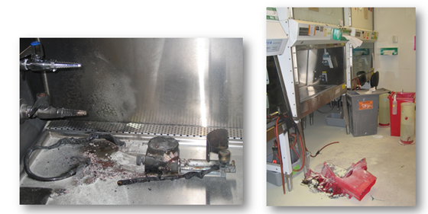
https://ehs.mit.edu/site/biosafety/biosafety-cabinets#certification
Rationale for no open flames
  - Poses a safety risk to personnel & equipment
  - Cabinet chamber is a sterile environment - a flame is not necessary for sterility
  - Disposable or autoclavable loops & plate spreaders are recommended; these replace the need for “flaming” a reusable loop/spreader
  - Heat inside the cabinet can damage the supply HEPA filters
  - Heat can interfere with the directional airflow causing disruption in the safety of the operator & interference in the sterility of the chamber/samples
- Newly installed BSC’s may not be connected to a gas source

Other ventilation equipment
There are a variety of different styles of ventilation equipment used under different conditions. Some provide containment, others do not. The nature of your material and whether the material needs to be handled in a sterile environment will determine what type of ventilation you need. Even different styles of Biosafety cabinets can vary in function and protection provided.
Equipment | Ventilation | Applications
 |  | Biohazardous Materials | Non-volatile toxic chemical and radionucleotides | Volatile toxic chemicals and radionucleotides
Chemical Fume hood | 100% non-filtered air | No | Yes | Yes
Clean Bench | 100% HEPA filtered supply air | No | No | No
Class I BSC | 100% HEPA filtered exhaust air | Yes | Yes | Yes, in minute quantities while canopy connected
Class II Type B1 | 60% HEPA filtered exhaust air, 40% recirculated HEPA filtered air | Yes | Yes | Yes, but in small amounts towards rear of cabinet
Class II type B2 | 100% HEPA filtered exhaust air | Yes | Yes | Yes
Class II Type C1 | HEPA filtered supply and exhaust air (varies on configuration) | Yes | Yes | Yes if connected to building exhaust
Class III | 100% HEPA filtered supply and exhaust air | Yes | Yes | Yes
Below is a discussion of other types of ventilation equipment and less common models of biosafety cabinets.
Other ventilation equipment
- Chemical Fume Hood
- Clean bench/laminar flow hood
- Animal transfer/Cage changing station
- Class I BSC
- Class II Type A1 BSC
- Class II Type B1 BSC
- Class II Type B2 BSC
- Class II Type C1 BSC
- Class III BSC (“glove box”)

Chemical Fume Hood
- Single pass air is exhausted by building exhaust fan and leaves air stack at top of building
  - Can be constant flow fume hood (less energy efficient)
  - Can be variable flow flume hood (more energy efficient as air flow is adjusted depending on whether the hood is in use)
- Lacks internal blower motor so is completely reliant on building exhaust fan to provide airflow
- Used with toxic chemicals
- Provides personnel protection
- No supply HEPA filters so workspace is a non-sterile environment (no product protection)
- No exhaust HEPA filters (so no environmental protection from biological agents; chemical concentration reduced to acceptable levels through dilution with environmental air)

Clean bench/laminar flow hood
- For use with nonhazardous sterile work (such as PCR or media preparation)
- Supply HEPA filter provides product protection
- No exhaust HEPA filter (so no personnel or environmental protection)
- Must not be used with hazardous material
  - No biological material
  - No hazardous chemicals
  - No radionuclides
- Some laminar flow hoods can be easily mistaken for a biosafety cabinet at a glance
- Safety tip - If the instrument blows air into your face, it is NOT a biosafety cabinet & provides no containment

Animal transfer station
- Generally used to reduce allergens when working with animals
- Supply HEPA filters provide some product protection
- Exhaust HEPA filter provides some room protection
- Does not provide personnel protection since the sash is open
- Must not be used with animals containing hazardous material:
  - No animals containing biohazardous material
  - No animals containing hazardous chemicals
  - No animals containing radionuclides

Class I BSC
- Original style of biosafety cabinet
- Only provided personnel and environmental protection
- No supply HEPA filter (no product protection); not a sterile chamber
- Largely replaced by Class II biosafety cabinets
- Only used in specialized circumstances where product protection is not needed

Class II Type A1 BSC
- Older style of biosafety cabinet
- Similar to Class II Type A2 except that the plenum is under positive pressure due to the motor placement
- Requires plenum seal to be leak tested
- Increased risk in that plenum seal leak could lead to an exposure to contaminated air due to the positive pressure
- Largely replaced by Class II Type A2 cabinets

Class II Type B1 BSC
- Used for biological work with higher concentrations of hazardous chemicals
- “Partial Exhaust” cabinet in that work done in front part of chamber is recirculated and work done in rear of chamber is completely exhausted
- Hazardous chemical work done in rear of chamber for complete exhaust
- Blower motor interlocked with building exhaust fan – if building exhaust fails, blower motor turns off to avoid pressurization & exposing operator to hazardous biological and chemical material
- Airflow complicated & requires special installation and recertification
- 3rd HEPA filters can require more expensive maintenance
- More energy efficient than a Class II Type B2 BSC, but more energy intensive than a Class II Type A2 with a canopy connection
- Only required for specialized situations where higher concentrations of volatile toxic chemicals must be used with biological material under sterile conditions

Class II Type B2 BSC
- Used for biological work involving higher concentrations of hazardous chemicals
- Similar to a chemical fume hood with HEPA filters
- “Total Exhaust” in that no air is recirculated
- Blower motor interlocked with building exhaust fan – if building exhaust fails, blower motor turns off to avoid pressurization & exposing operators to hazardous biological and chemical material
- Single pass air is very energy inefficient
- Airflow complicated and requires special installation and recertification
- Only required for specialized situations where higher concentrations of volatile toxic chemicals must be used with biological material under sterile conditions

Class II Type C1 BSC
- New style of cabinet that can function either as a Class II Type A2 cabinet or a Class II Type B cabinet
- Allows flexibility since the connection type can be modified to meet changing research needs
- More energy efficient than Class II Type B cabinets
- Has improved safety features for handling hazardous chemicals
- Multiple modes of operation:
  - Operate non-ducted for only biological material
  - Can be canopy connected for work with biological material and small amounts of chemicals (may require facilities work)
  - Can be hard ducted for work with biological material and higher concentrations of chemicals (may require facilities work)
- Currently only one vendor manufacturers this cabinet
- Please visit the Labconco website for more details

Class III BSC (“glove box”)
- Gas-tight containment chamber with gas-tight sealed sash
- User has no direct contact with the samples
- Samples enter chamber through a bypass chamber
- User interacts with samples through thick gloves built into chamber
- Differs from a chemical glove box used to handle chemicals under inert gas conditions in that Class III BSC’s are under negative pressure whereas chemical glove boxes are generally under positive pressure

References
- U.S. Department of Health and Human Services; U.S. Public Health Services; Centers for Disease Control and Prevention; U.S. National Institutes of Health (2009). Biosafety in Microbiological and Biomedical Laboratories, 5th edition, 2009, pp.290-325.
- ABSA Principles & Practices of Biosafety, Containment Equipment module, 2014, Paul Meechan, Hallie Hoskins; ABSA International
- Eagleson Institute, Safety Cabinet Technology, Introduction to Biological Safety Cabinets module, 2016, Dave Stuart
- Degree Controls website: https://degree-controls-inc.myshopify.com/pages/airflow-monitors

Appendix A
